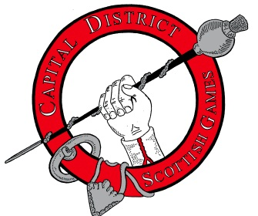
Registration Form for Athletic Competition
Name:
Address:
City: State: Country:
Zip:
Phone: E-Mail:
Competition Class
Saturday Sunday
Men’s Open Pro Amateur Men
Men’s Masters (45+) Lightweight Amateur Men

Men’s Senior Masters (60+) Women
Indicate Shirt Size (Circle one): S, M, L, XL, XXL, XXXL
Registration Fee: $35.00 Check payable to “Capital District Scottish Games” or “CDSG”
Mail Completed Form and registration fee to:
Bill Schmitt, Chairman
CDSG Highland Athletics
209 Consaul Road
Albany, NY 12205-3607

